1. Lauched the instance
2. Installed java
3. Download tomcat server
4. Started the tomcat
5. Installed jenkins
6. Launch jenkins using <http://13.201.194.41:8080/jenkins/>
7. Create job named “assignment”

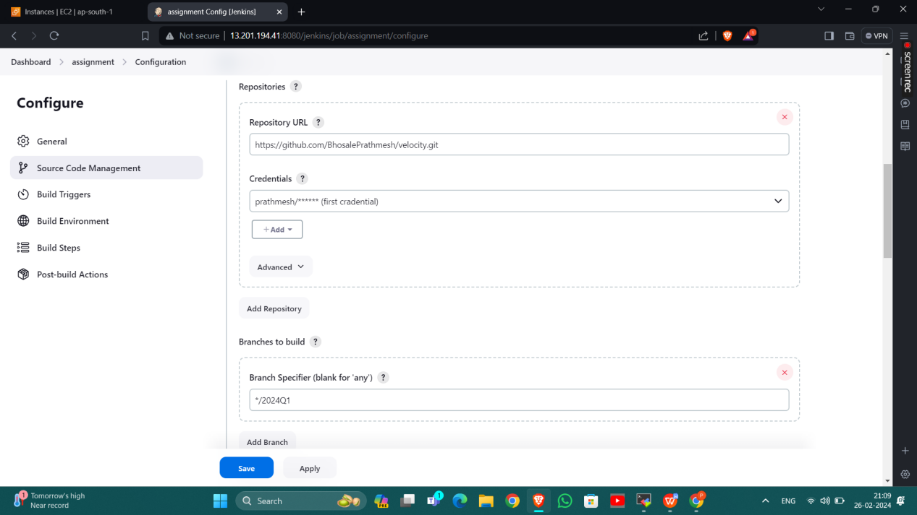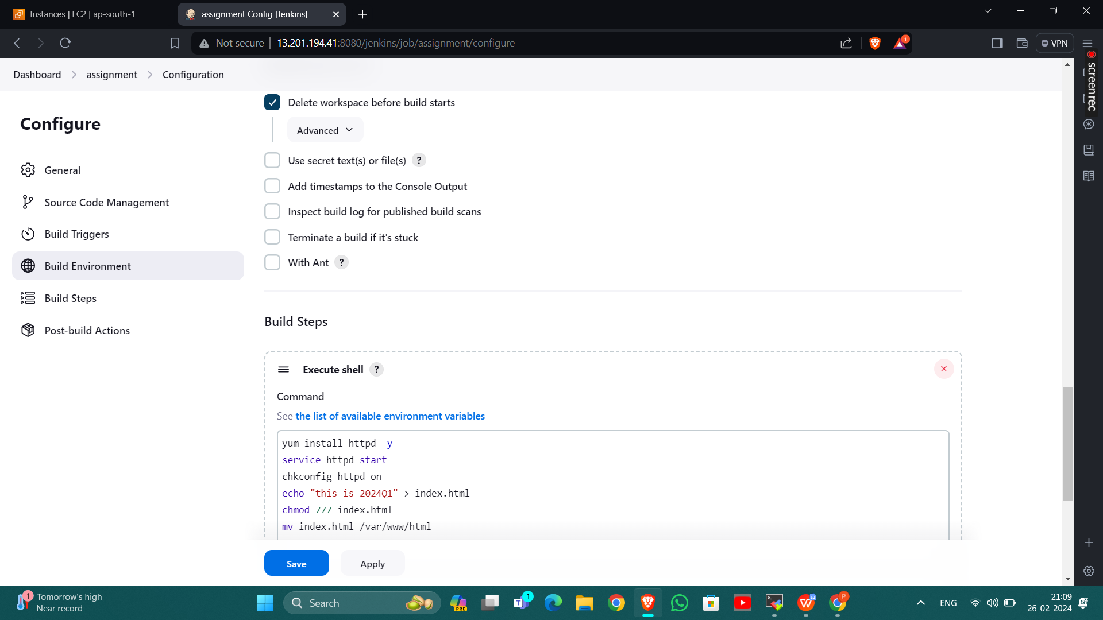

2024Q1 branch with apache httpd

2024Q2 branch with apache httpd

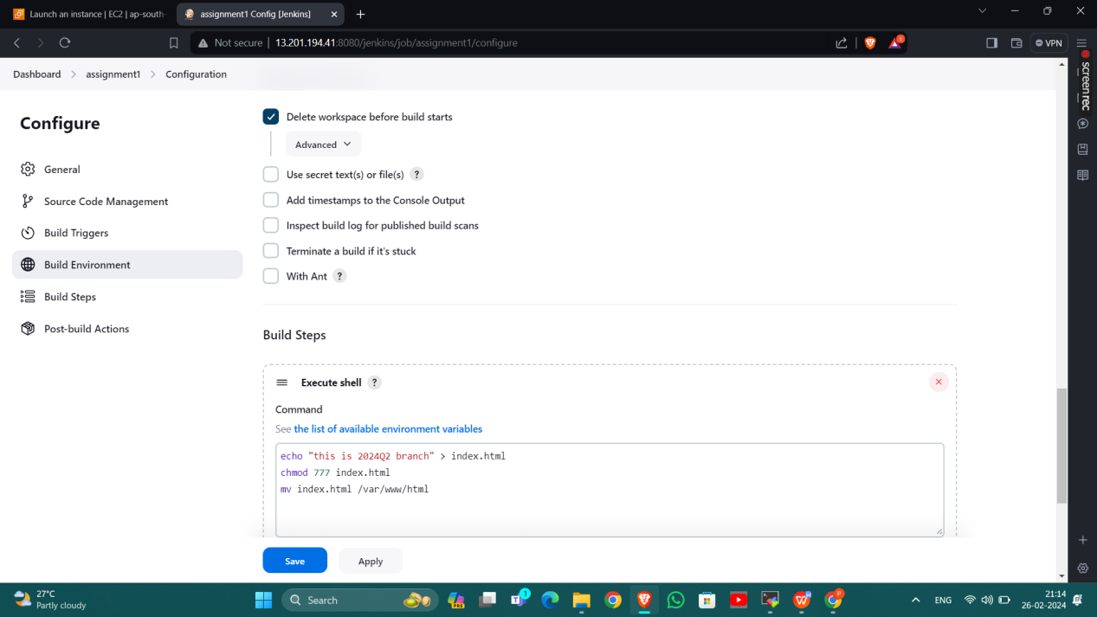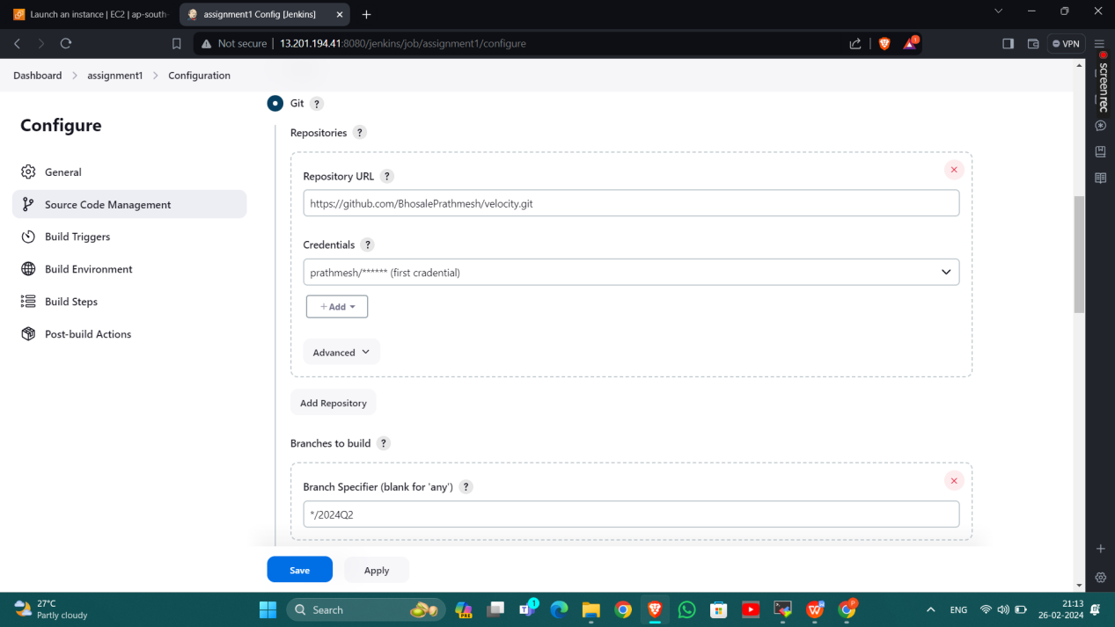

2024Q3 branch with apache httpd

